Threat Hunting and Remediation Using Agentic AI with Python and Microsoft Sentinel
This project demonstrates the design and implementation of an AI-assisted SOC workflow that supports threat hunting, investigation, and automated response using Microsoft Sentinel, Defender for Endpoint, and OpenAI. The agent translates natural language security concerns into KQL queries, analyzes enterprise telemetry, and executes controlled response actions with strict cost and safety guardrails. The result is a scalable, low-cost automation approach that enhances analyst efficiency without sacrificing oversight.

Introduction
This document walks through the process of building and testing an AI-powered agent designed to support threat hunting and remediation workflows within a Security Operations Center (SOC).
The goal of this project is to explore how AI agents can be integrated into a real-world SOC analyst workflow—specifically, how they can assist with querying security telemetry, interpreting results, and accelerating investigation efforts.
While technical steps are covered, the emphasis is placed on how the solution supports real-world security workflows, rather than on low-level implementation details.

Starting/Preparing the Environment
To begin, a local development environment must be set up to support Python-based development and secure communication with both OpenAI and Microsoft Azure services.

Step 1: Install Python and Set Up the IDE
The first requirement is installing Python on a Windows machine. Python serves as the foundation for the AI agent and is used to orchestrate API calls, process security logs, and format outputs.
For development, Visual Studio Code (VS Code) was selected as the Integrated Development Environment (IDE) due to its lightweight nature and strong Python support.
To optimize VS Code for this project, the following extensions were installed from the VS Code Marketplace:
- Python – Enables Python syntax support, debugging, and execution
- Black Formatter – Automatically formats Python code to ensure consistency and readability
This setup provides a clean, efficient environment suitable for rapid experimentation and iteration.
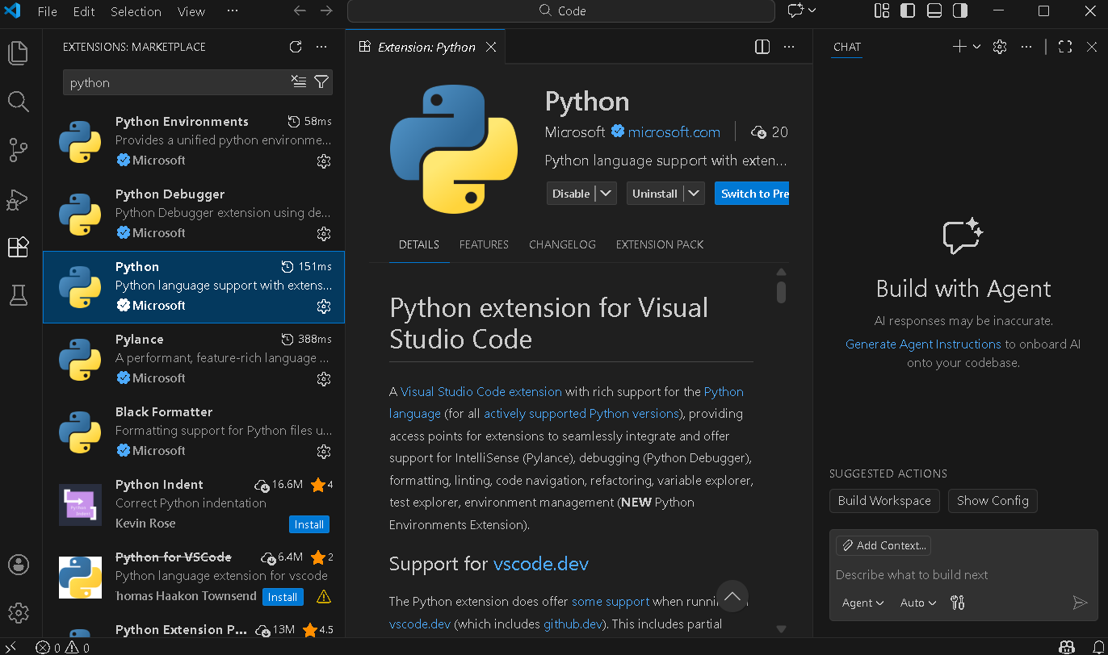
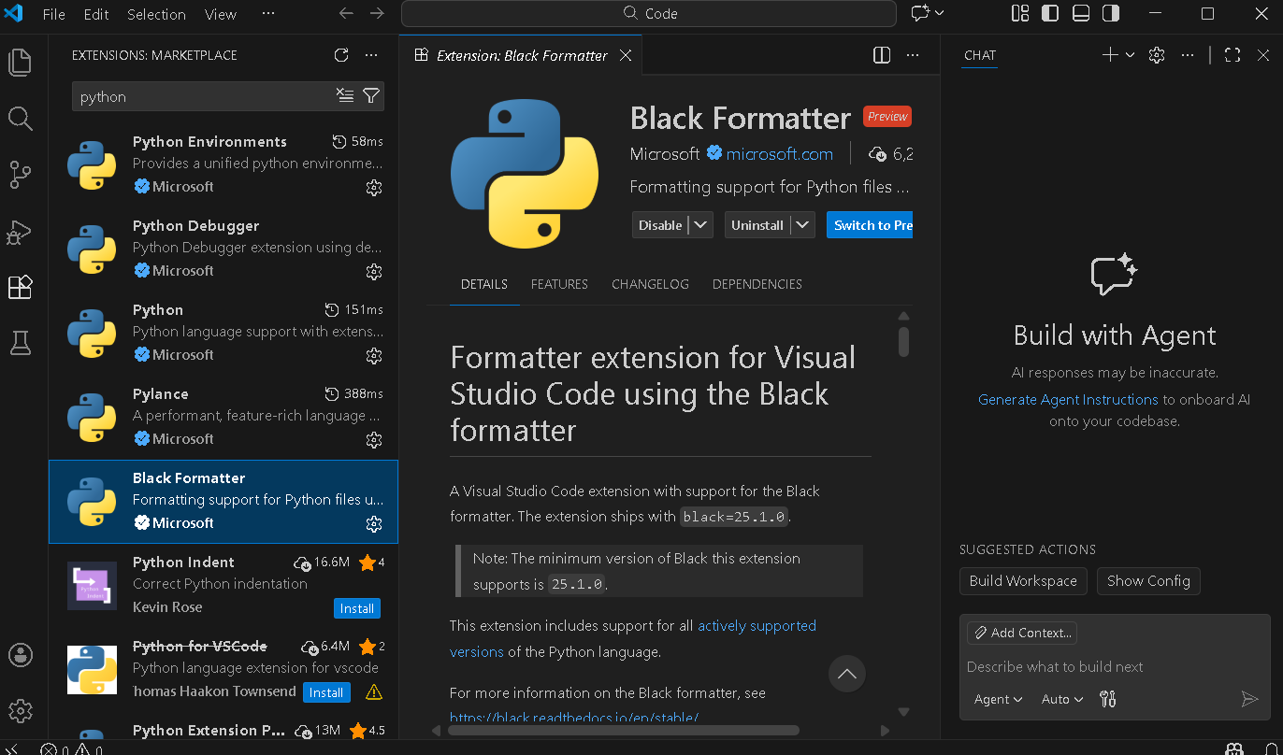

Step 2: Preparing the AI Agent Template
With the environment configured, a basic Python template is created to serve as the starting point for the AI agent. This template establishes the structure needed to send prompts, receive responses, and later integrate external data sources.
At this stage, an OpenAI API key is generated, and the account is funded with a small amount of usage credit. This key allows the program to securely communicate with OpenAI’s services. Usage costs are minimal and are discussed later in the project.
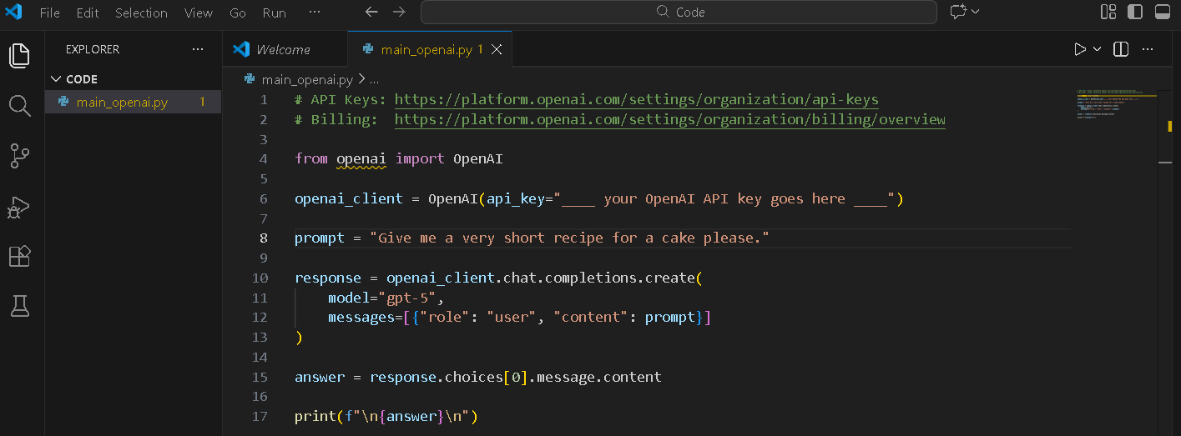
Before inserting the API key into the code, it is necessary to install the OpenAI Python library. This is done using the following command:
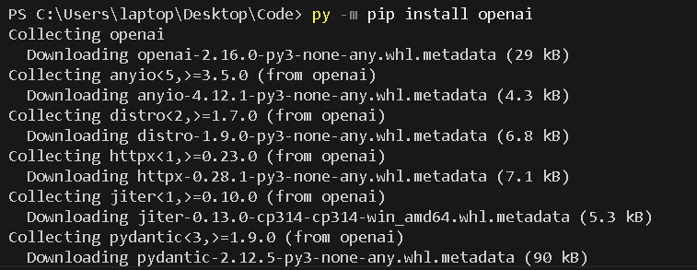
Once installed, the API key is added to the appropriate location in the script.

Step 3: Verifying OpenAI API Connectivity
To confirm that the environment is configured correctly, a simple test prompt is sent to the OpenAI API:
“Give me a very short recipe for a cake.”
Receiving a valid response confirms that:
- The API key is working
- The program can successfully send requests
- Responses are being returned and processed correctly
This validation step ensures the AI agent’s core communication mechanism is functioning before introducing additional complexity.
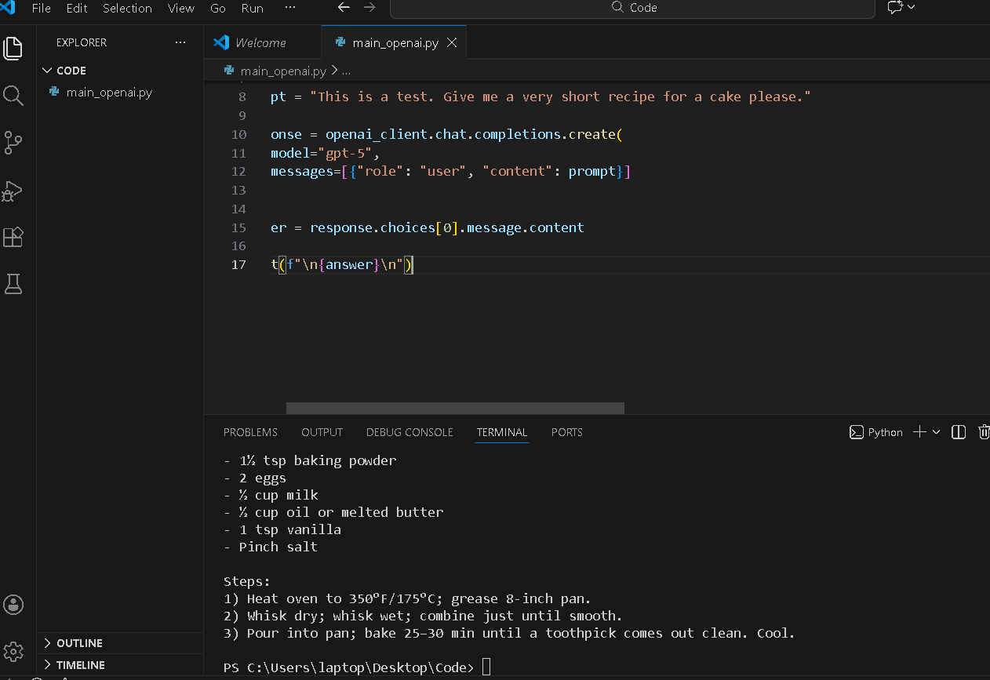

Step 4: Introducing the Security Lab Environment
For realistic testing, this project uses a controlled lab environment known as Cyber Range. This environment simulates an enterprise organization that is continuously exposed to security incidents and breaches, providing realistic telemetry for threat hunting scenarios.
Using a lab environment allows the AI agent to operate against real-world-style data without risk to a production system.
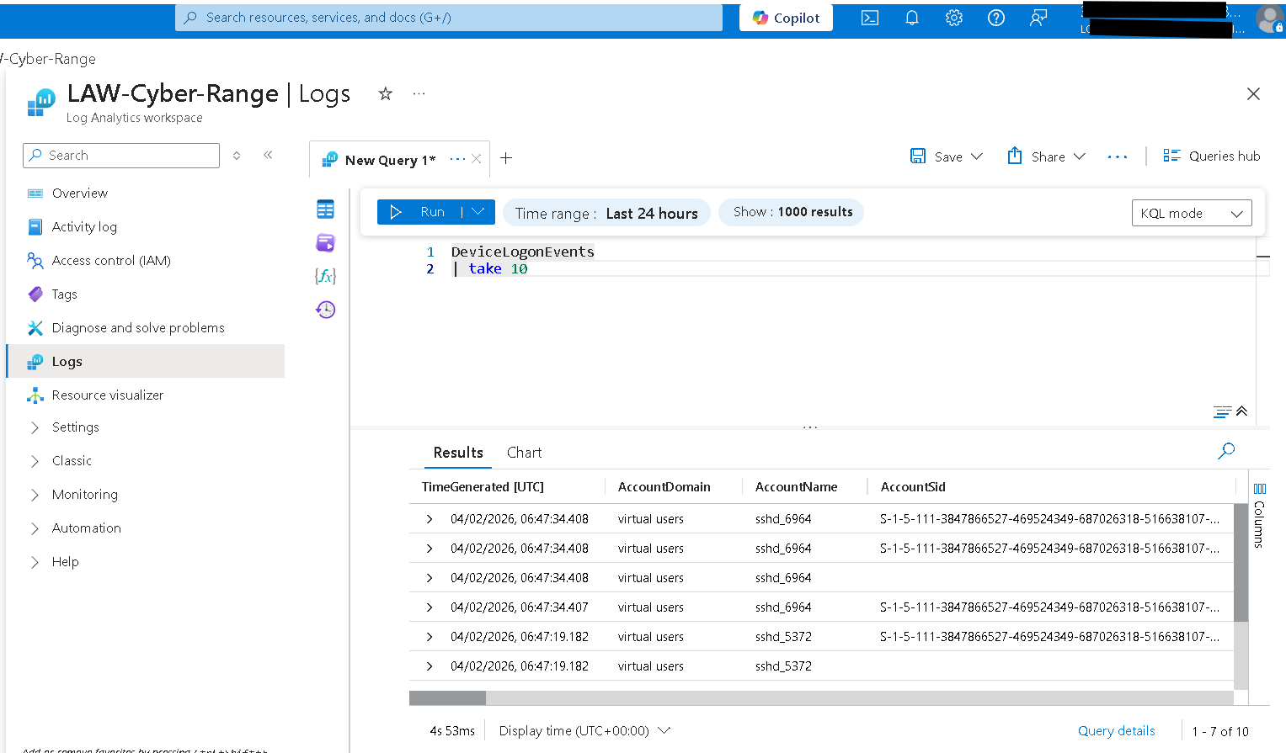

Step 5: Connecting to Azure Log Analytics
The next step is integrating the AI agent with Microsoft Azure’s Log Analytics workspace, which serves as the data backend for Microsoft Sentinel.
At this point, the project has:
- Verified connectivity to the OpenAI API
- Begun validating connectivity to Azure security data
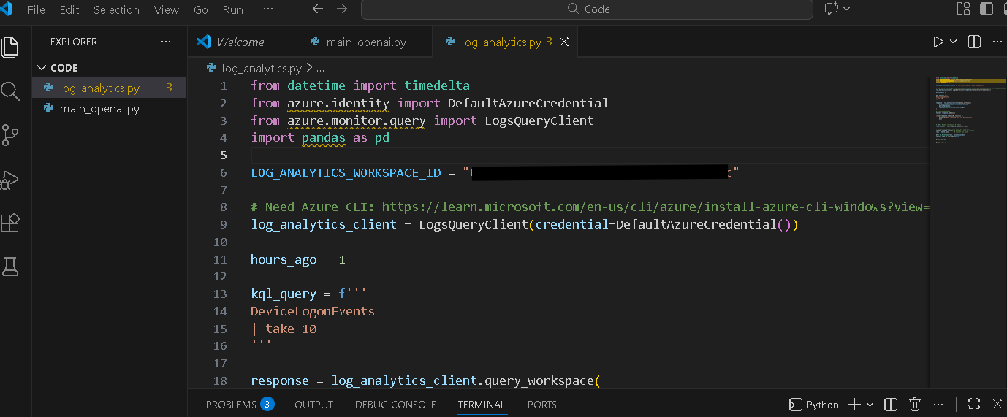
To enable communication with Azure services, several Python libraries are required:
py -m pip install azure-identity
py -m pip install azure-monitor-query
py -m pip install pandas
- azure-identity handles authentication
- azure-monitor-query enables Log Analytics queries
- pandas is used to structure and format data in a human-readable way
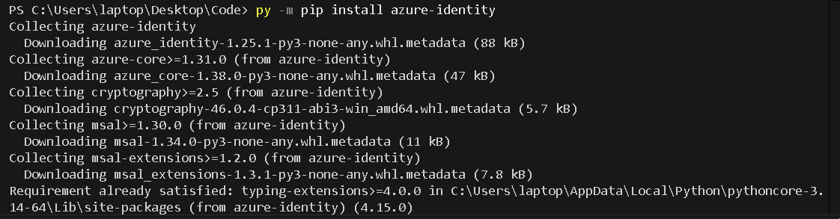
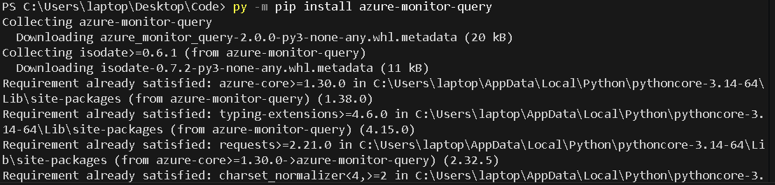

Step 6: Authenticating with Azure
In addition to Python libraries, the Azure CLI must be installed on the local machine. The CLI is used to authenticate against an Azure tenant that has:
- Microsoft Sentinel enabled
- A user account with appropriate permissions to query logs
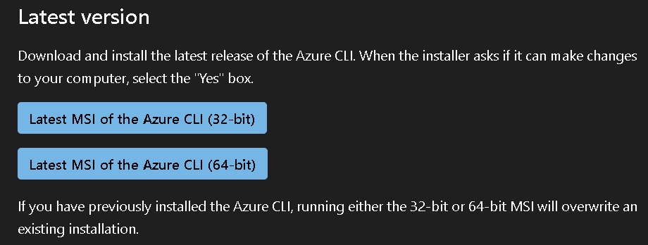
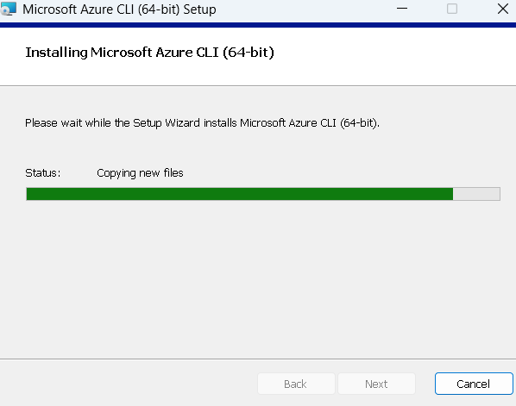
Once installed, the Azure CLI is connected to the tenant, allowing the Python script to inherit authenticated access.
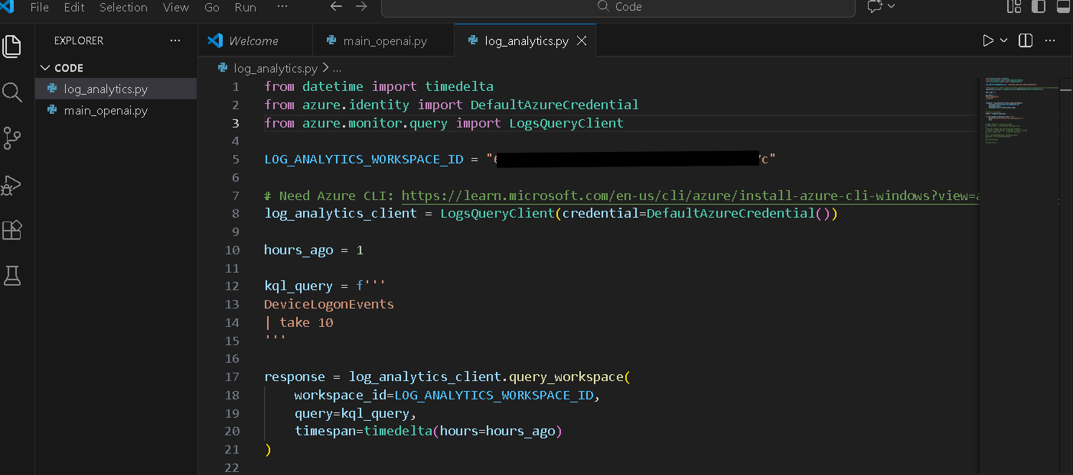

Step 7: Testing Log Analytics Queries
With authentication complete, a test query is executed against the Log Analytics workspace. The script sends a KQL (Kusto Query Language) query to Azure, retrieves the results, and outputs them within the program.
At this stage, the raw output confirms that:
- The agent can successfully query Sentinel data
- Log data is being retrieved as expected

We can see the KQL query that the program will pass to the Azure Log analytics workspace instance.
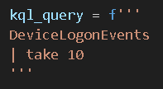
With the output being:
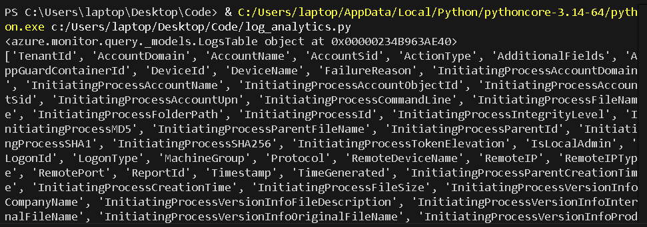
More complex queries are then tested to validate consistency and flexibility. These tests help confirm that the agent can handle increasingly realistic investigation scenarios.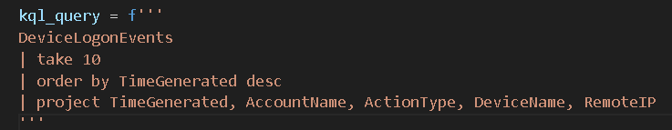
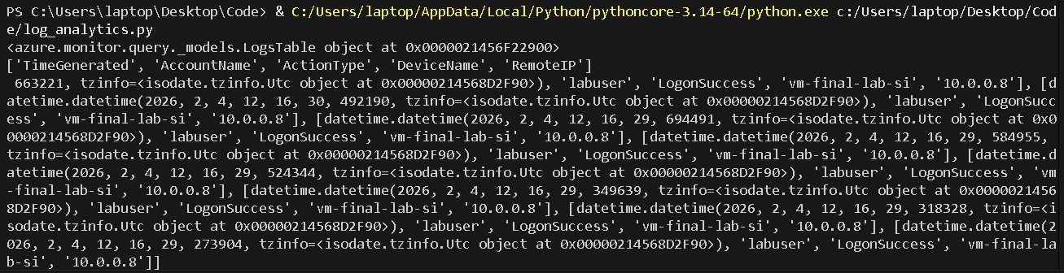

Step 8: Improving Data Readability
Finally, additional code is introduced using pandas to convert the raw query results into structured tables. This step transforms machine-oriented output into a format that is easier for humans to interpret and analyze.
Improving readability is a critical step, as it mirrors how SOC analysts and hiring managers would expect insights to be presented—clear, structured, and actionable.
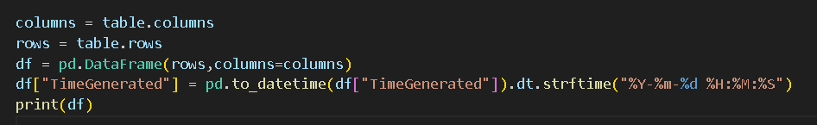
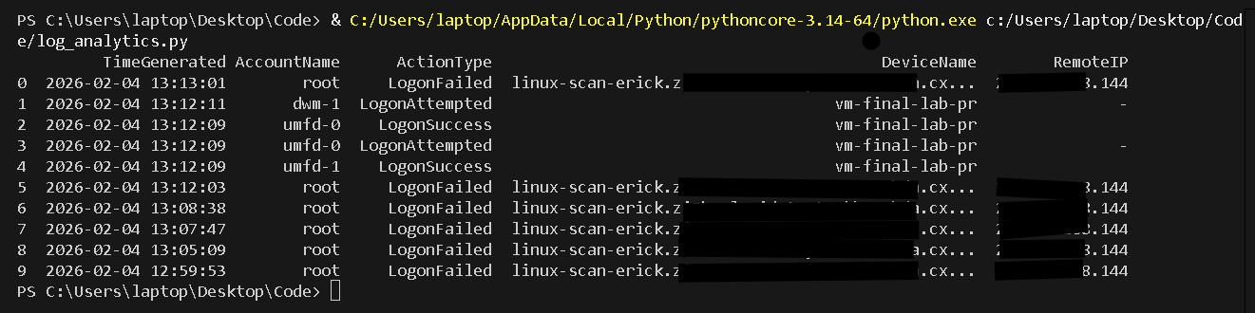
We can be even more specific with our searches:
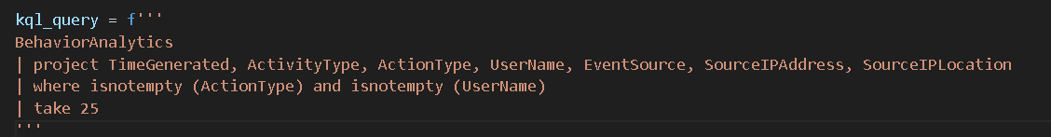
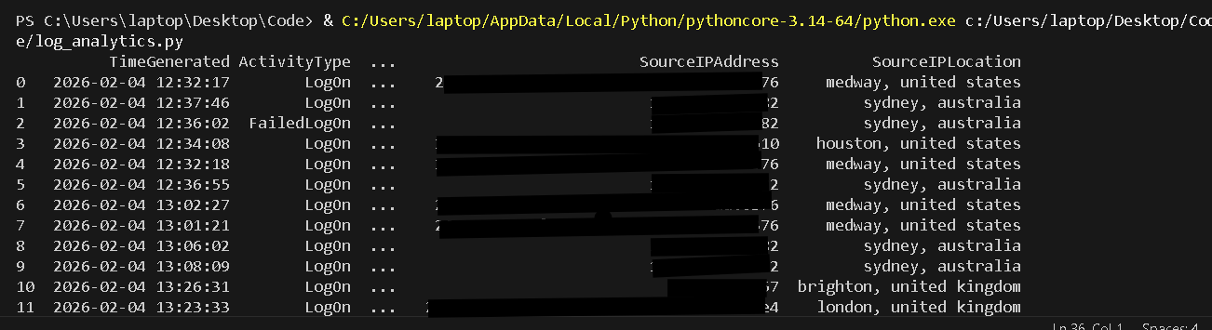

Adding the Agent

Step 1. The Groundwork for AI Functionality
At this stage, the focus shifts from environment setup to expanding the program’s functionality and formally introducing the AI agent into the workflow.
Initially, the agent itself is not yet active within the program. Instead, the groundwork is laid by extending how data is retrieved from the Azure Log Analytics workspace. Additional tables are pulled into the application and exposed as variables within a dedicated function. This abstraction simplifies how the program requests data and maintains synchronization with the Log Analytics workspace.
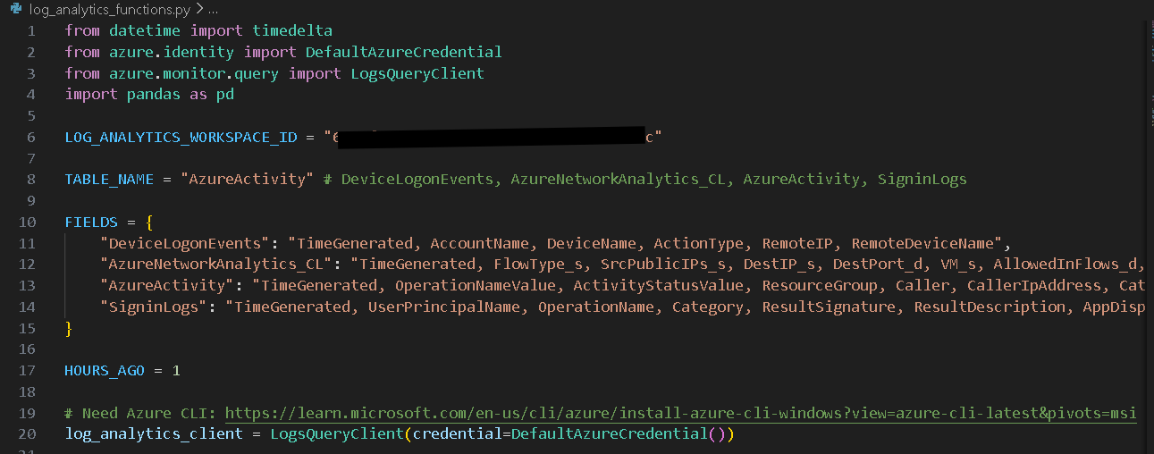
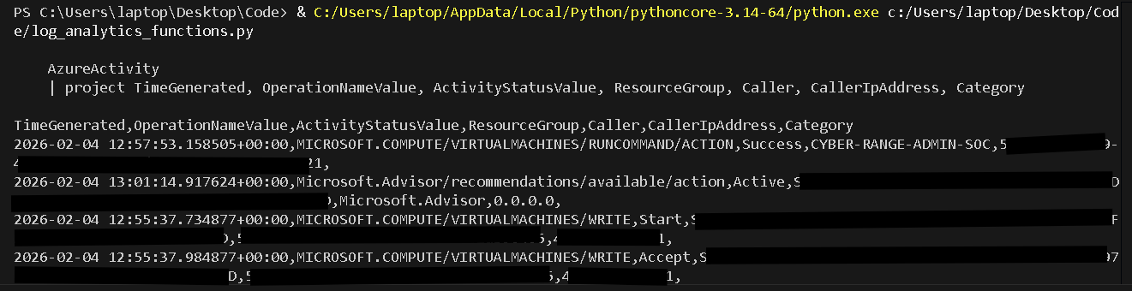
By structuring data access in this way, specific fields can be predefined, filtered, and manipulated directly from the derived tables returned by the function. This design choice allows the program to remain modular and adaptable, making it easy to tailor the agent’s inputs to different environments, datasets, or investigative use cases without rewriting core logic.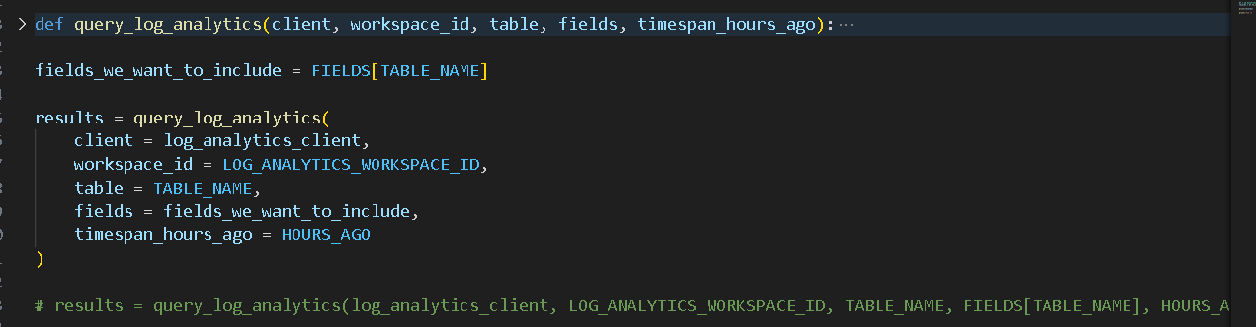
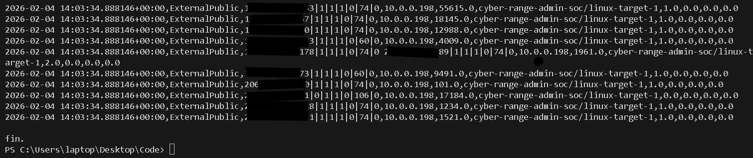
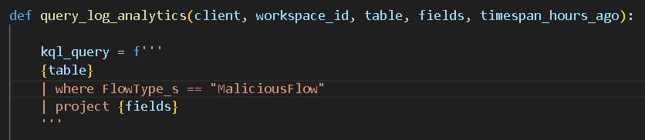
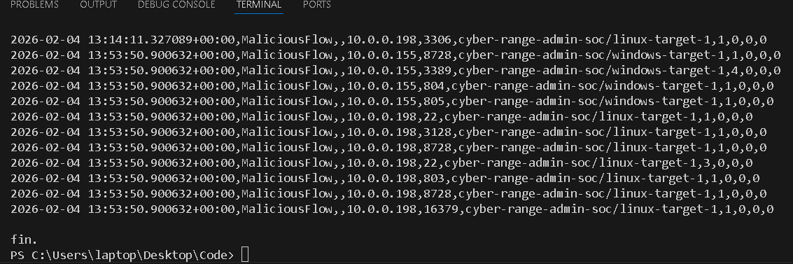
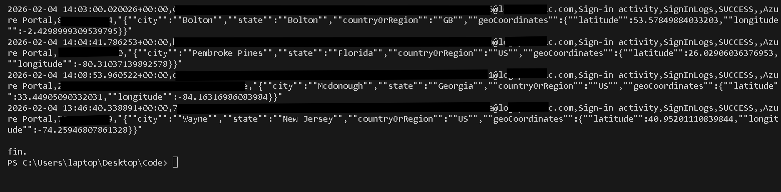
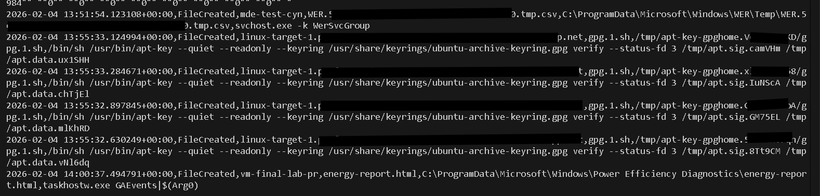
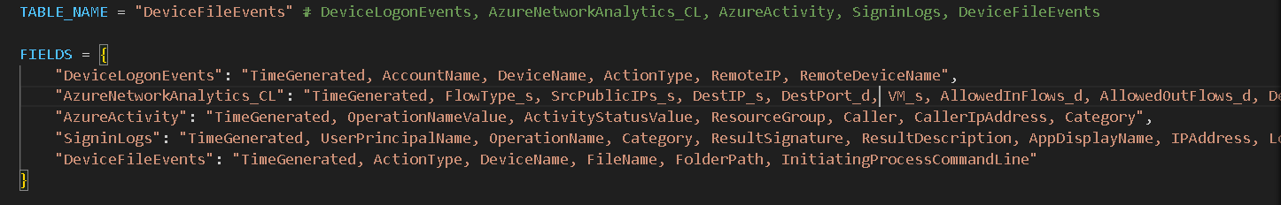

Step 2. Introducing AI Functionality to the program
With the data layer in place, AI capabilities are then integrated into the program. Initial testing focuses on cost awareness and model selection, ensuring the solution remains practical for ongoing use.
The program is designed to support multiple AI models, allowing the user to specify which model should be used at runtime. Cost-efficient models are defined explicitly within the code, giving flexibility to balance performance and operational expense.
For this implementation, GPT-5 is selected as the active model.
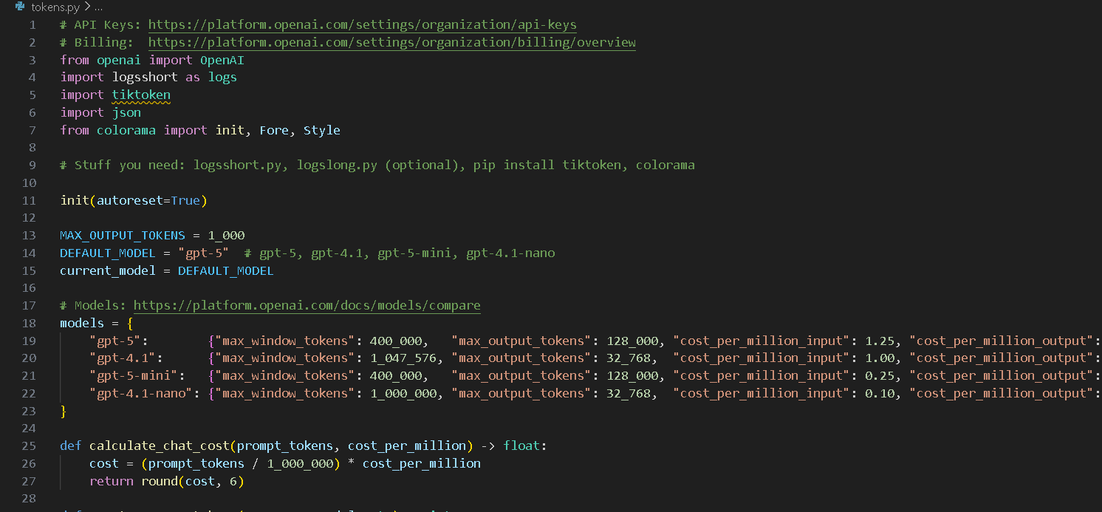
This modular approach to model selection allows the program to evolve over time, making it straightforward to switch models or adjust configurations as requirements change.

Testing the Agent

Step 1. Evaluating Inputs and Managing Cost
With the AI model integrated, the next step is providing the agent with data to analyze.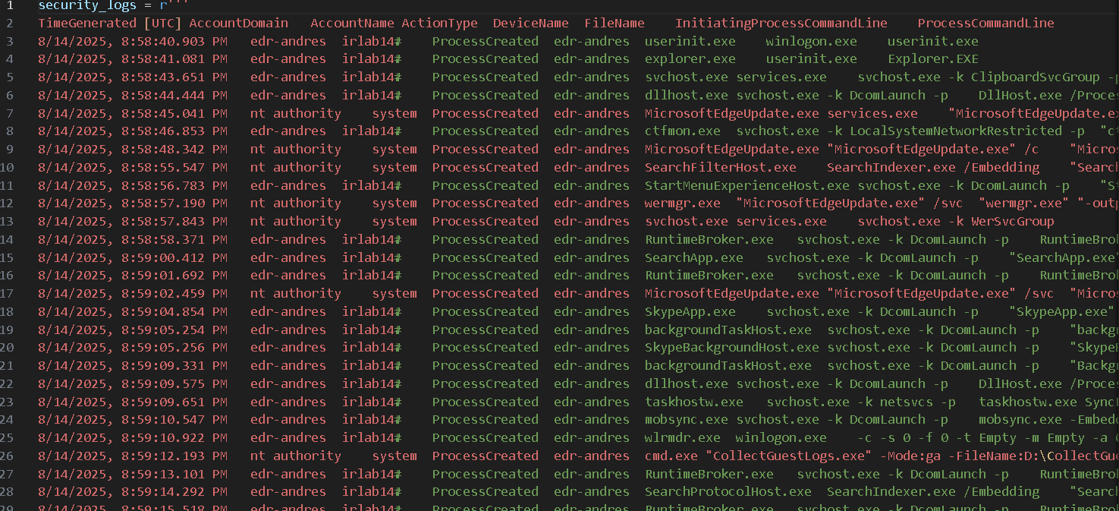
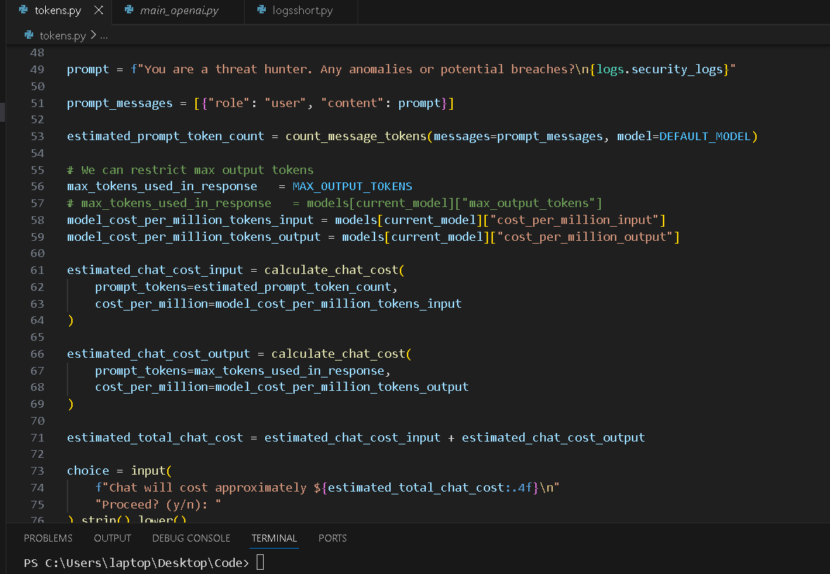
Before any analysis is performed, the program evaluates the projected cost of the request. This ensures that each investigation is assessed for resource usage prior to execution.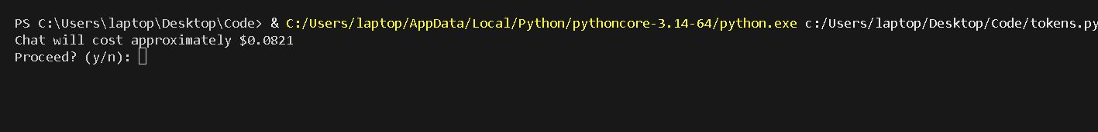
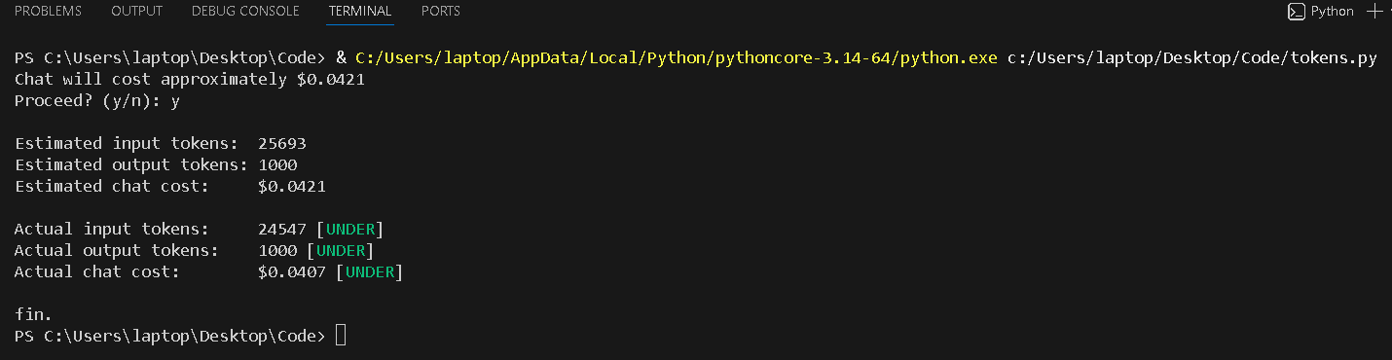
When token usage is maximized, the cost of a single investigation is approximately $0.08. To prevent unexpected or unnecessary spending, guardrails are implemented by explicitly defining a maximum token limit. In this case, a limit of 1,000 tokens is later applied—an amount that proves sufficient for the intended use case while keeping costs consistently low.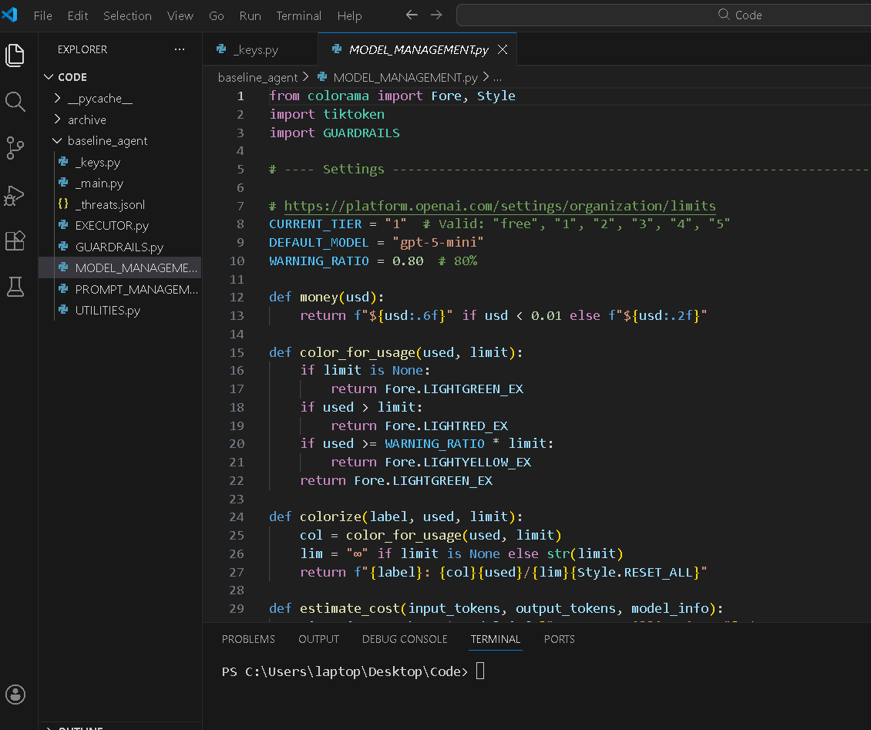
With cost controls in place, the AI agent functionality is fully enabled within the program.

Step 2. Agent Behaviour and Threat Identification
The AI is configured to operate under a defined SOC Analyst role, established through system-level instructions within the program. This ensures the agent’s behaviour aligns with how a human analyst would approach an investigation—prioritizing context, relevance, and risk.
The agent connects to the Azure Log Analytics workspace through the Azure CLI, while OpenAI handles the natural language processing and reasoning behind each request. This separation allows the program to securely access enterprise telemetry while leveraging AI for interpretation and decision support.
To validate functionality, the following test prompt is issued:
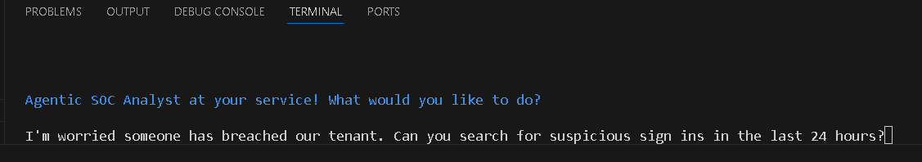
“I’m worried someone has breached our tenant. Can you search for suspicious sign-ins in the last 24 hours?”
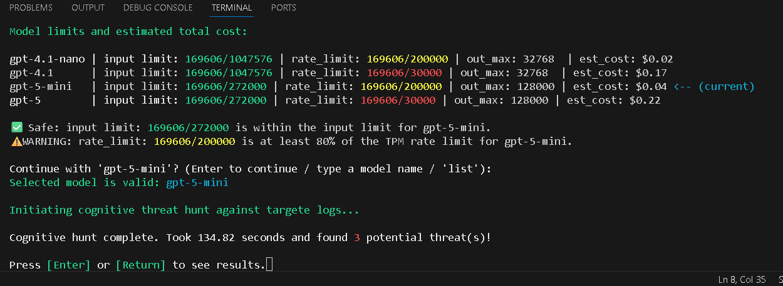
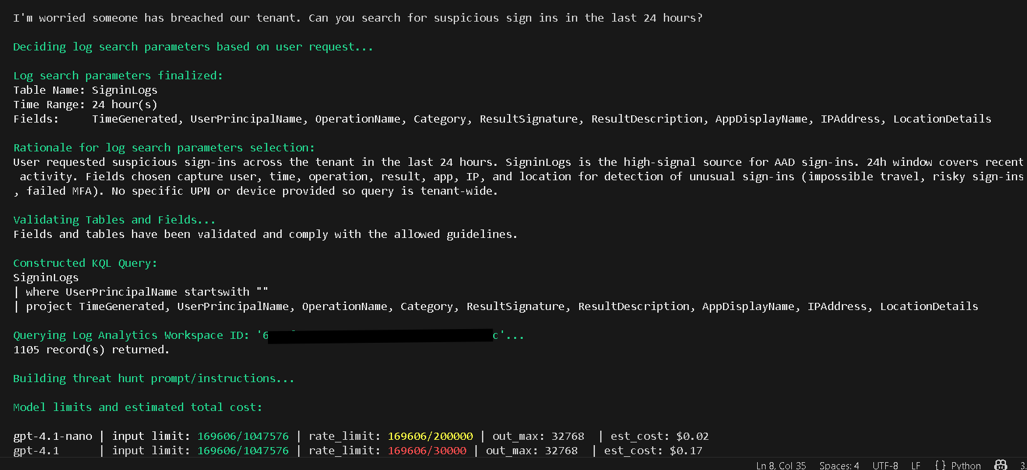
From this prompt, the program automatically derives intent and generates an appropriate KQL query based on the requested investigation whilst also managing cost. Multiple query fields—such as time range, authentication context, and sign-in characteristics—are dynamically created by the AI.
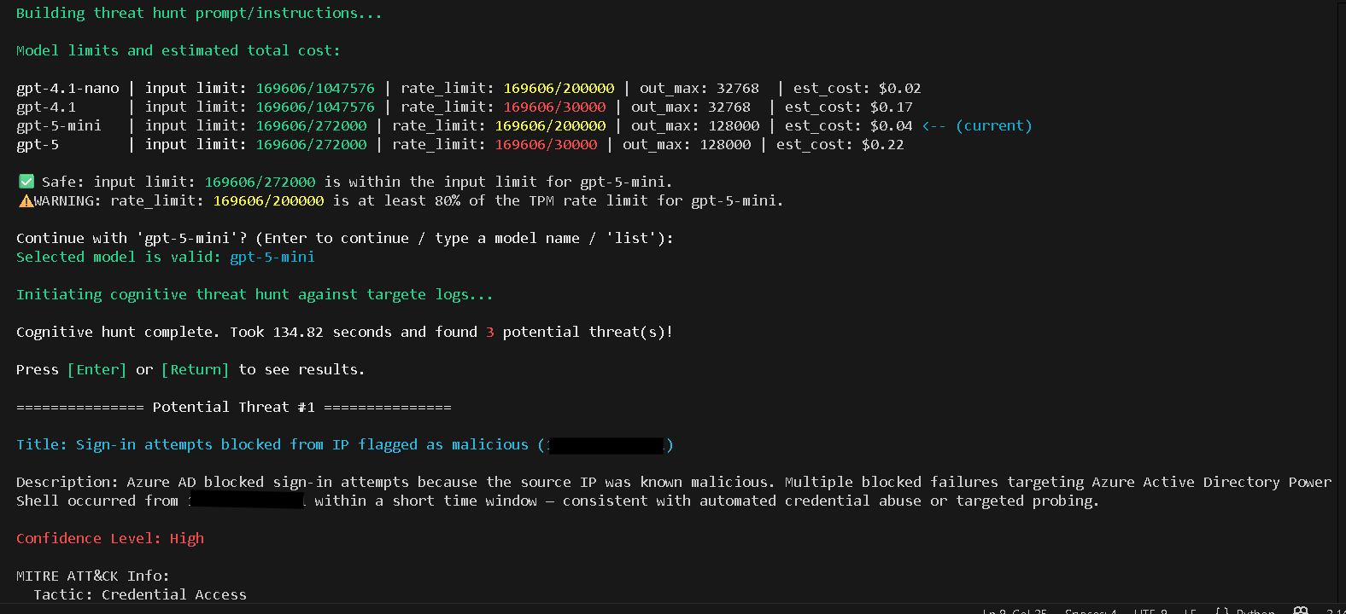
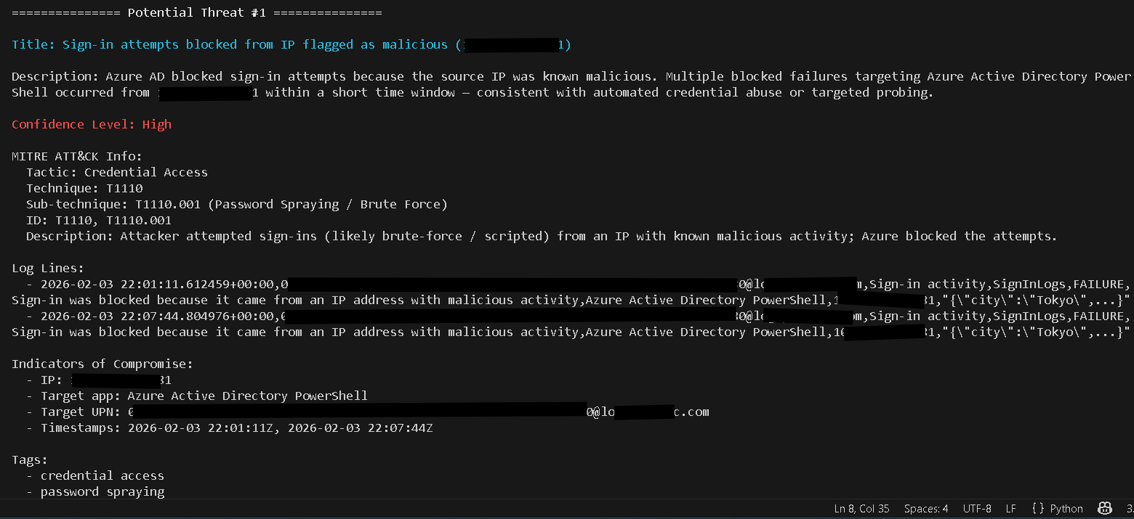
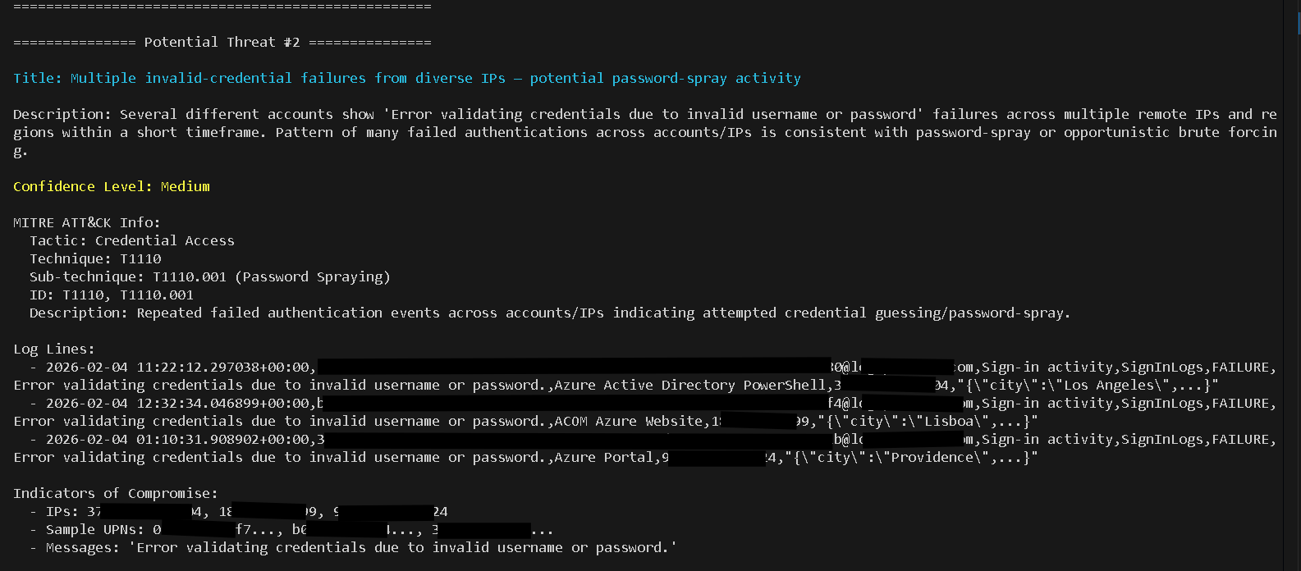

The agent then analyzes the data returned from the Log Analytics query, identifies potential threats, and records the findings in a structured JSON file for later review.
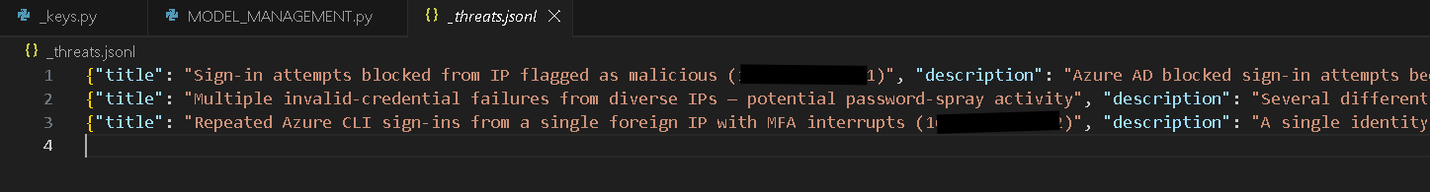
Each identified event is enriched with:
- A mapped attack category or technique
- Relevant investigative or response guidelines
- A confidence level to assist analyst judgment
This approach mirrors how SOC analysts’ triage and assess alerts, enabling faster review while maintaining transparency and analyst oversight.

Step 3: Automated Threat Response
With the core investigation workflow in place, the final phase of the project introduces automated threat response capabilities through Microsoft Defender for Endpoint (MDE). This enhancement transforms the agent from a passive analysis tool into an active participant in incident response.
To support this expanded capability, additional guardrails are implemented to ensure actions are deliberate, controlled, and auditable. These safeguards are designed to prevent overreaction, limit scope, and ensure that automated responses occur only when specific criteria are met as seen by the results.

Step 4: Automated Investigation and Response Workflow
At this stage, the agent can take investigative findings and translate them directly into response actions.
When the AI identifies suspicious or malicious activity, it now:
- Generates a custom KQL query based on the investigation context
- Searches historical and real-time records within the Log Analytics workspace
- Correlates affected users, sessions, and endpoints
- Determines whether a response action is warranted

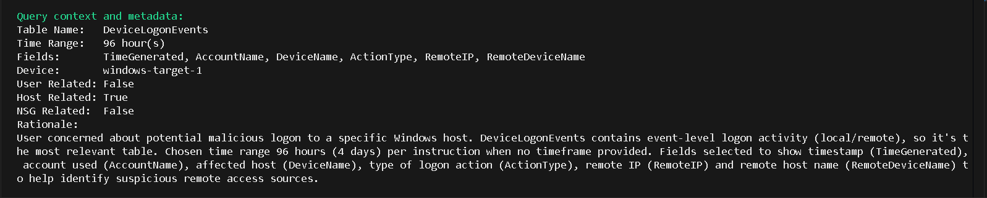
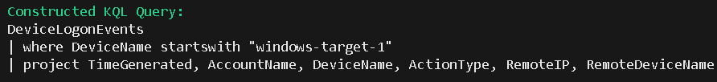
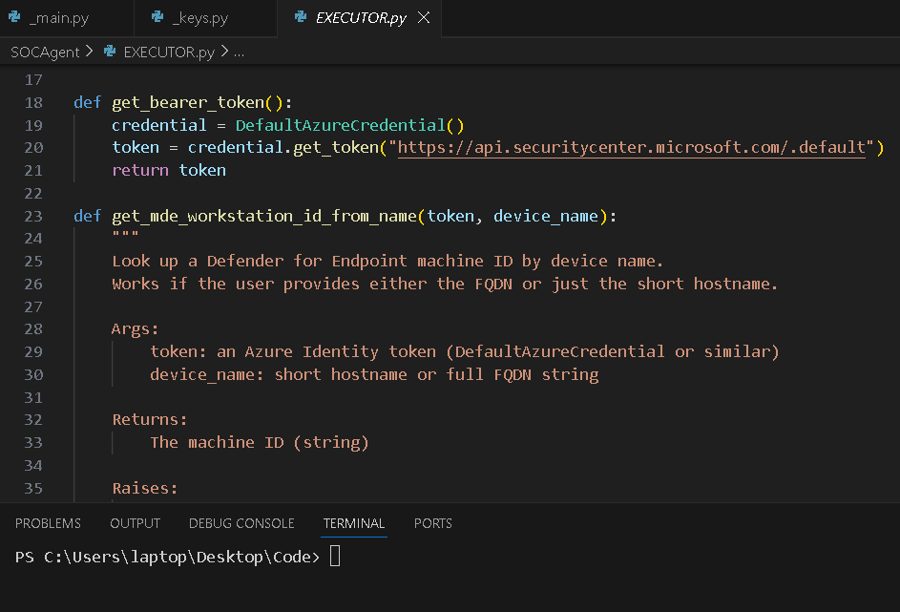
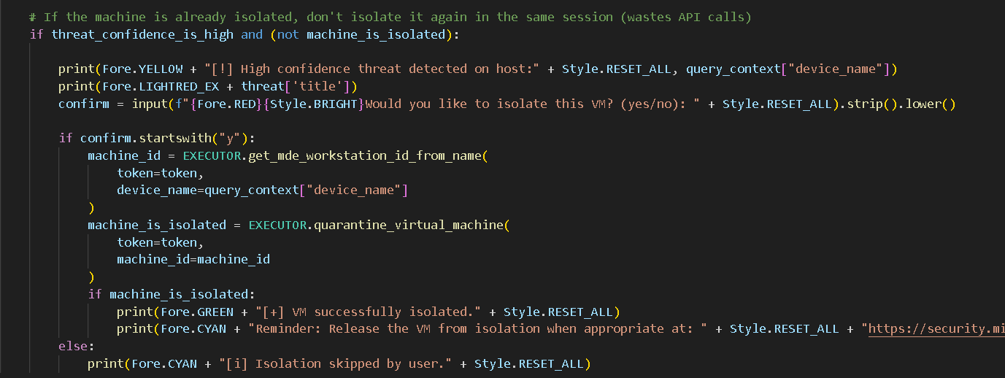
If malicious activity is confirmed and falls within predefined thresholds, the agent initiates an automated response through Microsoft Defender for Endpoint. In this implementation, the primary response action is isolating affected virtual machines, effectively containing the threat while further analysis can continue.
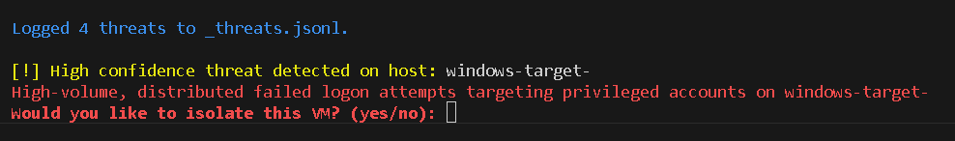
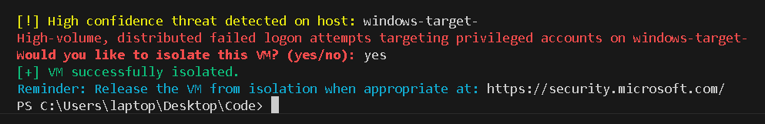
This mirrors real-world SOC escalation workflows, where containment is prioritized to limit impact while preserving evidence.

Step 5: Action Validation and Logging
Once a response action is issued, the agent monitors the status returned by MDE.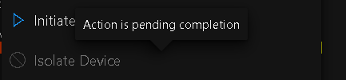
A “pending completion” status confirms that the action was successfully submitted and is in progress, providing immediate feedback that the containment step has been initiated.
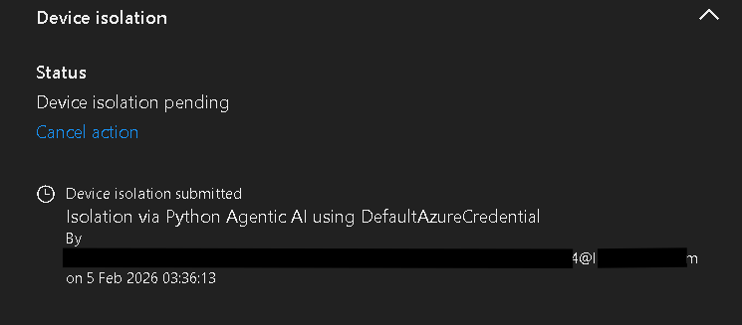
All actions taken by the agent—including the triggering indicators, investigative context, and response outcome—are logged for transparency and review. This ensures that every automated decision can be traced, audited, and validated by an analyst.

Step 6: Cost Optimization and Operational Efficiency
Throughout development, cost efficiency was treated as a core design requirement rather than an afterthought. By implementing strict token limits, selecting cost-effective models, and validating usage before execution, the average cost of an investigation was reduced to well below one cent per run.
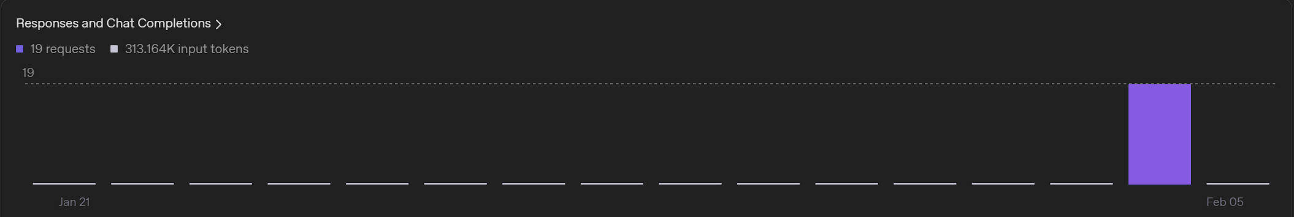
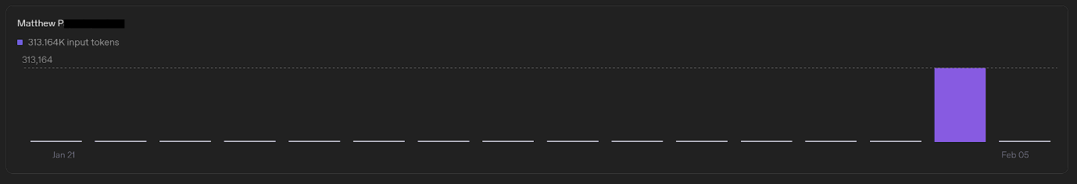
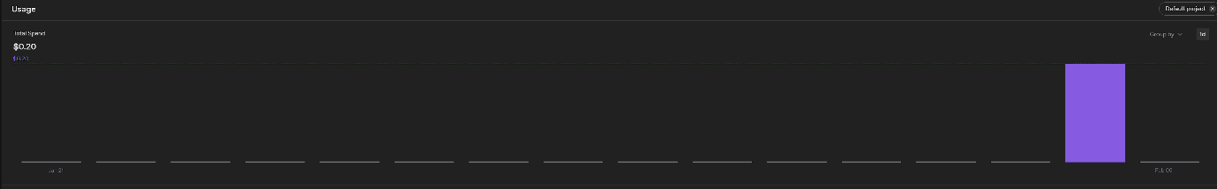

These controls demonstrate how AI-driven security workflows can remain financially viable at scale, even when performing repeated or automated investigations. By combining guardrails with modular model selection, the agent balances analytical depth with predictable, minimal operating costs—making it suitable for continuous SOC usage rather than isolated experimentation.

Summary
By the conclusion of this project, the AI agent is capable of:
- Interpreting natural language security concerns
- Dynamically generating KQL queries
- Analyzing enterprise security telemetry
- Identifying and classifying potential threats
- Applying cost controls and operational guardrails
- Executing automated containment actions through MDE
- Logging findings and responses for analyst review
This project demonstrates how AI agents can be responsibly integrated into SOC workflows—not as a replacement for analysts, but as a force multiplier for SOC Teams that accelerates investigations, reduces manual effort, and enables faster, more consistent response to security threats.
From initial detection to automated containment, the agent showcases a practical and scalable approach to modern threat hunting and remediation.

